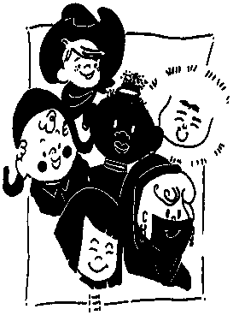
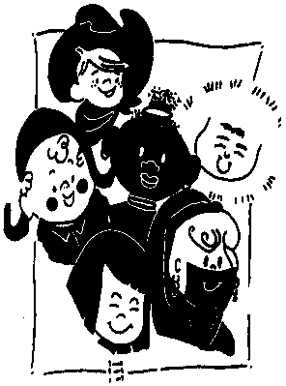
UnitedPlaycentre
3 Gatley Road, Rondebosch
(021) 686-3228
FEE STRUCTURE FOR 2022
Deposit/Placement fee (refundable off last month of attendance fee) R2300
Sibling discount R150/month

Nursery (0- 3 years) Annual Bi-annualTermly Monthly
Half day 7:30 – 12:15R39744 R20976 R10764R3680
Full day7:30 – 17:30R51084 R26964 R13836 R4730

Pre-school (3- 5 years) Annual Bi-annual Termly Monthly
Half day 7:30 – 13:00 39744 R20976 R10764 R3680
Full day 7:30 – 17:30 51084 R26964 R13836 R4730

Aftercare/holiday care
Casual aftercare (12:30 – 17:30) R80
Casual holiday care (past pupils Grade R and younger) R220 per day

Intra Murals
These activities are included in the school fees
Clamber club Ladybirds Frogs Butterflies
Wriggle and Rhyme Ladybirds Frogs Butterflies Starfish Puppies Monkeys
Little Leaders Frogs Butterflies Starfish Puppies Monkeys
Gross Motor Programme Frogs Butterflies Starfish Puppies Monkeys
Bakerman Ladybirds Frogs Butterflies Starfish Puppies Monkeys

Show levy (annual amount can be paid monthly)Ladybirds/Frogs/ButterfliesStarfish/Puppies Monkeys
R245R1065 R1100
School fees include
• Tissues, wet wipes for cleaning faces, anti-bacterial handwash, hand sanitizer, paper towels, plastic bags (for soiled clothing)
Fees exclude:
• All extra-mural activities
• Special dietary requirements (due to allergies or for religious reasons)
- Attached additional requirements
School fees are calculated on an annual basis and are charged monthly over a period of 12 months (January to December)
School closes between Christmas and New Year and on all public holidays.

United Playcentre Requirements

An extra set of clothing (in a Ziplock bag)
Apron with sleeves
Water bottle
Sun hat (summer months) if your child does not have a visor hat
Sunblock
Hairbrush/comb
Blanket for rest time (winter months)
Beanie (winter months)
A face mask/visor/ visor hat for children over 2 years
5l ice cream container
Jumbo crayons (1- 5 year olds)
Jumbo Koki’s (3-5 year olds)
Disposable gloves for all children requiring nappy changes (available from school @ R30)
Wet wipes x 1 packet for all children requiring nappy changes
Cream for bottoms if not using Fissan Paste or Vaseline
Babies
Formula bottles ready made for the day
2 Sippy cups – one for tea time and snack time and one for access to water all day

PLEASE NOTE THAT WE ARE CURRENTLY NOT ALLOWING SCHOOL BAGS AT SCHOOL DUE TO COVID PROTOCOLS.

