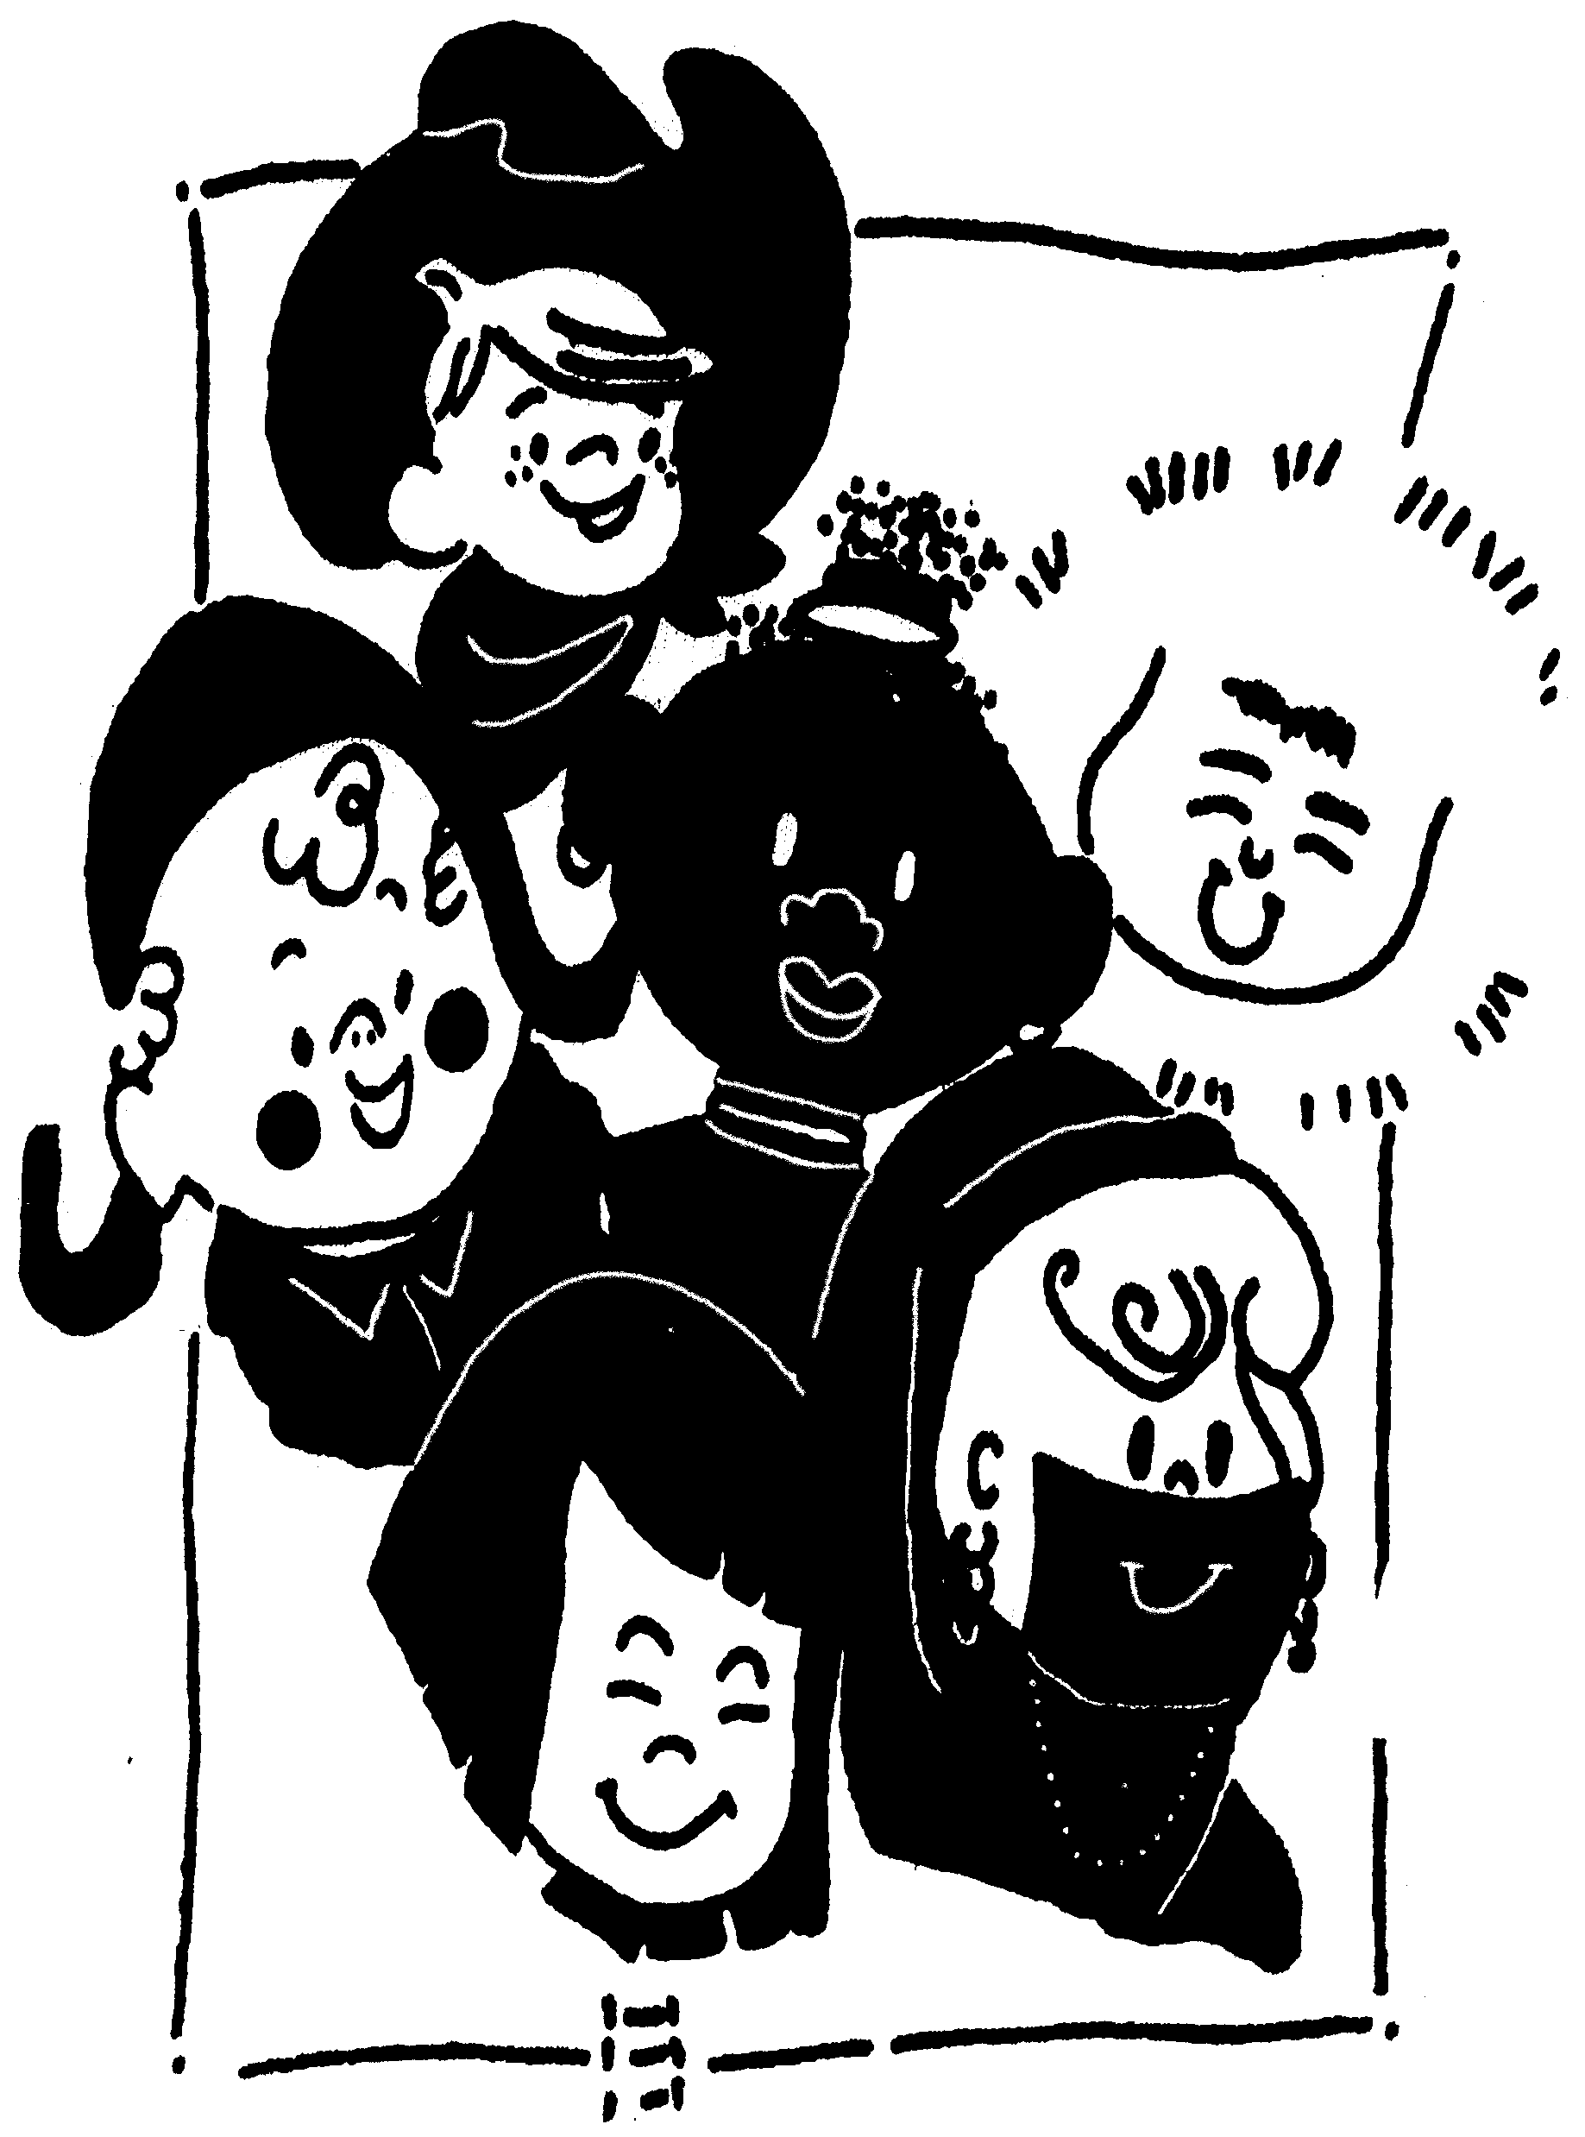United Playcentre
3 Gatley Road, Rondebosch
(021) 686-3228

FEE STRUCTURE FOR 2024

Fees are payable 12 months of the year from January to December.

Payment options for fees are as follows:

Monthly – R5350.00 Full day, R4350 Half day. Payment due by the 2nd of each month in advance

Quarterly – R15649 Full day
R12724 Half day Payment due 2 Jan, 2 April, 2 July, 2 October

Half yearly R30495 Full day
R24795 Half day Payment due 2 Jan, 2 July

Annually R57780 Full day
R46980 Half day Payment due 31st of January.

Fees must be paid directly into the school’s bank account. Please use your child’s name and surname as the reference.

Banking details United Playcentre, First National Bank 50191209102, Rondebosch Branch 250655

Deposits

For new children an acceptance deposit of R2650 is payable. This deposit of R2650 will be deducted from your child’s last month’s fees. Failure for your child to fill the vacancy will result in the full deposit being retained.

A term written notice (3 months) is required if a child is withdrawn from the school during the year. Failing which the parent is still responsible for the term fees.

Included in fees

Class | Clamber club | Little leaders | GMP | Wriggle + Rhyme | Bakerman | Kinderkinetics
Busy bee |  |  |  |  |  | Y
Ladybird | Y |  |  | Y |  | Y
Frog | Y |  | Y | Y | Y | Y
Butterflies | Y |  | Y | Y | Y | Y
Starfish |  | Y | Y | Y | Y | Y
Puppies |  | Y | Y | Y | Y | Y
Monkeys |  | Y | Y | Y | Y | Y

